**Gerar hash de um arquivo.**

Dell@DESKTOP-GRVGP51 MINGW64 /c/Workspace

$ openssl sha1 hello.txt

SHA1(hello.txt)= dc15a75dd1ac4d01102f743a35c2e8fdcd848a3c

Dell@DESKTOP-GRVGP51 MINGW64 /c/Workspace

$

**Objetos básicos do GIT  
Blobs**

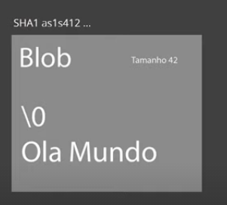

Tree

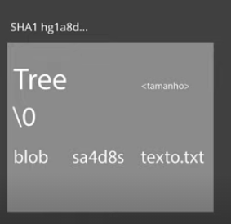

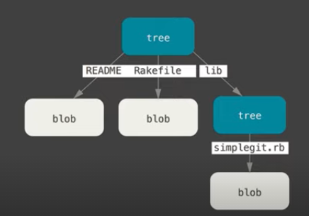

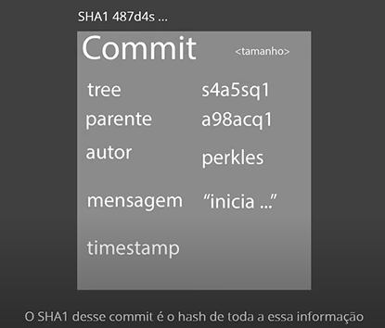

Pratica

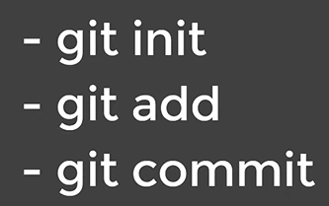

**Trabalhando com o GIT.**

Dell@DESKTOP-GRVGP51 MINGW64 /c/Workspace/livro-receitas (master)

$ git add *

Dell@DESKTOP-GRVGP51 MINGW64 /c/Workspace/livro-receitas (master)

$ git commit -m "commit inicial"

[master (root-commit) 86fd98b] commit inicial

1 file changed, 27 insertions(+)

create mode 100644 strogonoff.md

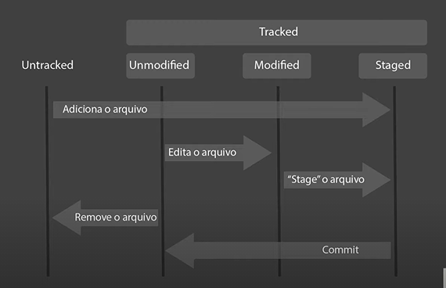

Repositórios

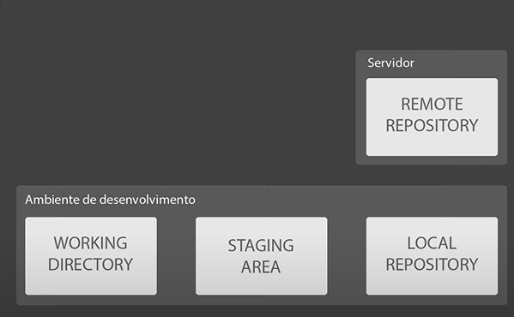

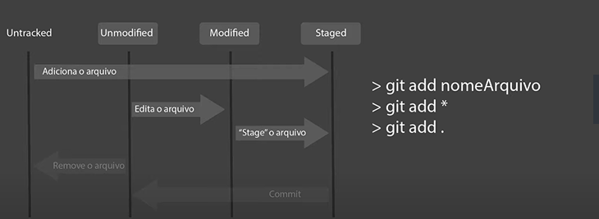

Dell@DESKTOP-GRVGP51 MINGW64 /c/Workspace/livro-receitas (master)

$ git remote add origin https://github.com/tiagosm1/livro-receitas.git

Dell@DESKTOP-GRVGP51 MINGW64 /c/Workspace/livro-receitas (master)

$ git branch -m main

Dell@DESKTOP-GRVGP51 MINGW64 /c/Workspace/livro-receitas (main)

$ git push -u origin main

Enumerating objects: 8, done.

Counting objects: 100% (8/8), done.

Delta compression using up to 4 threads

Compressing objects: 100% (6/6), done.

Writing objects: 100% (8/8), 1.31 KiB | 446.00 KiB/s, done.

Total 8 (delta 0), reused 0 (delta 0), pack-reused 0

To https://github.com/tiagosm1/livro-receitas.git

* [new branch] main -> main

Branch 'main' set up to track remote branch 'main' from 'origin'.

Dell@DESKTOP-GRVGP51 MINGW64 /c/Workspace/livro-receitas (main)

$ git status

On branch main

Your branch is up to date with 'origin/main'.

nothing to commit, working tree clean

Dell@DESKTOP-GRVGP51 MINGW64 /c/Workspace/livro-receitas (main)